**Ubuntu Server MariaDB Configure**

root@otrs:~# apt install mariadb-server mariadb-client –y

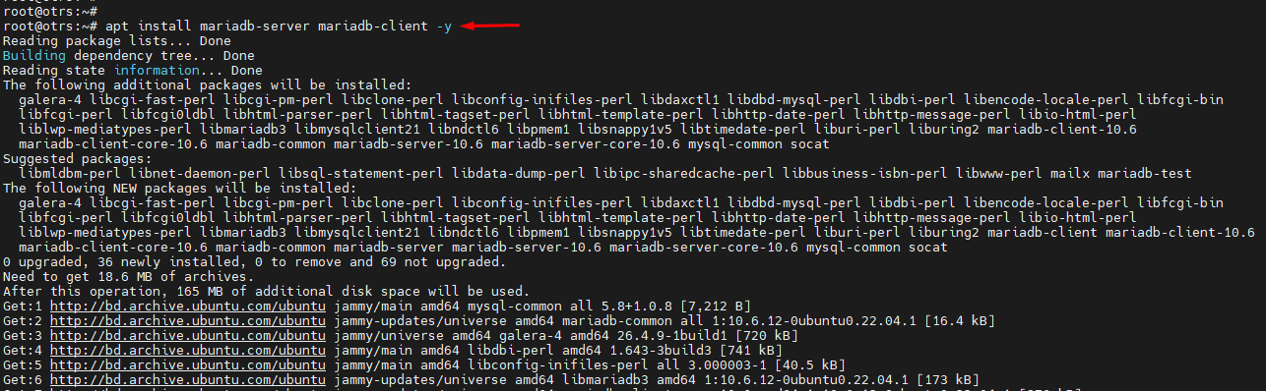

root@otrs:~# apt install -y software-properties-common

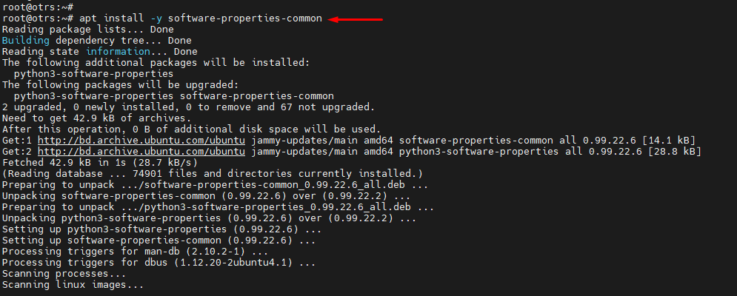

root@otrs:~# add-apt-repository 'deb [arch=amd64,arm64,ppc64el] https://mariadb.mirror.liquidtelecom.com/repo/10.6/ubuntu focal main'

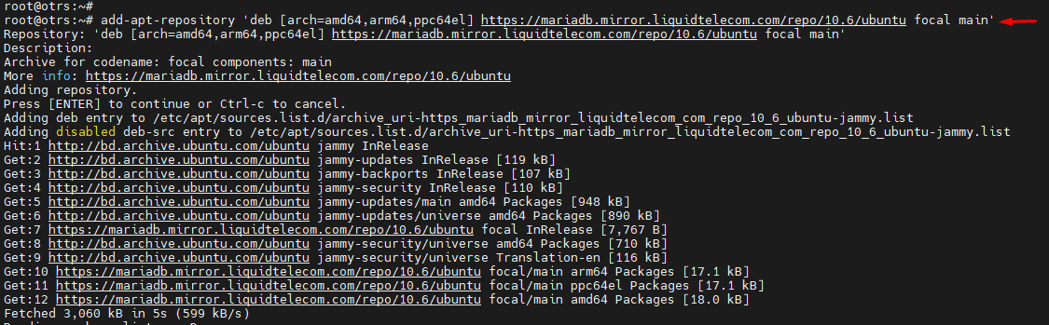

root@otrs:~# apt update && sudo apt install -y mariadb-server mariadb-client

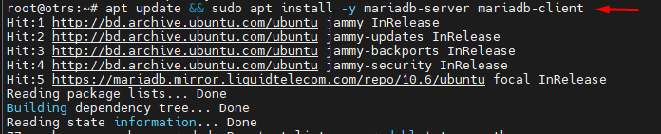

root@otrs:~# mariadb –version

mariadb Ver 15.1 Distrib 10.6.12-MariaDB, for debian-linux-gnu (x86_64) using EditLine wrapper

root@otrs:~# systemctl status mariadb

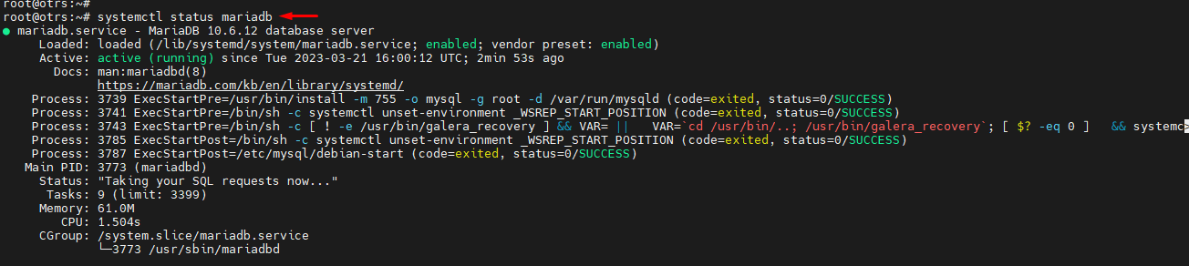

root@otrs:~# systemctl start mariadb

root@otrs:~# systemctl enable mariadb

Sorce Link: https://www.cherryservers.com/blog/how-to-install-and-start-using-mariadb-on-ubuntu-20-04

root@otrs:~# mysql_secure_installation

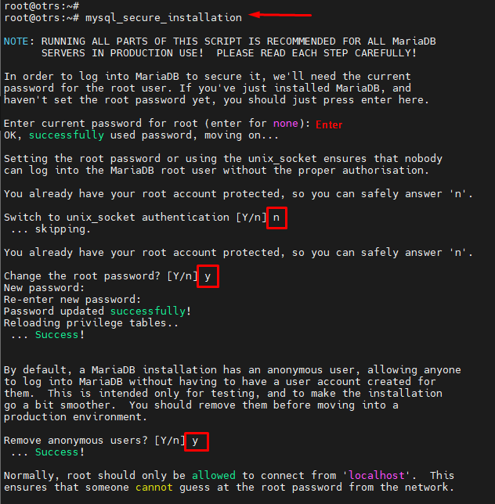

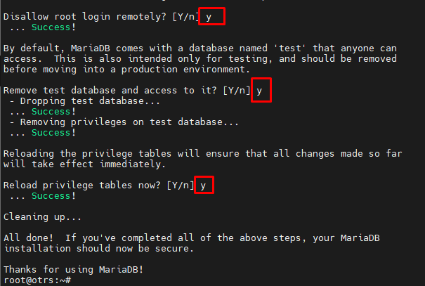

root@otrs:~# mariadb -u root –p

MariaDB [(none)]> show databases;

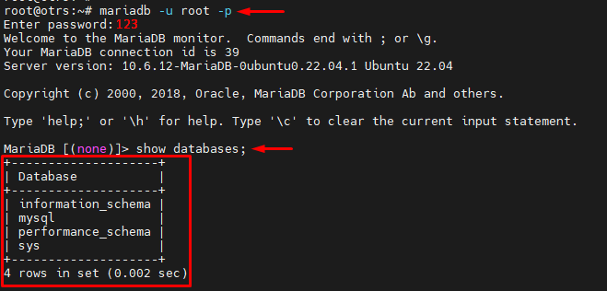

MariaDB [(none)]> CREATE USER 'ikbal'@'localhost' IDENTIFIED BY '123';

MariaDB [(none)]> GRANT ALL PRIVILEGES ON *.* TO 'ikbal'@'localhost';

MariaDB [(none)]> FLUSH PRIVILEGES;

MariaDB [(none)]> exit

root@otrs:~# mariadb -u ikbal –p

MariaDB [(none)]> SELECT host, user FROM mysql.user;

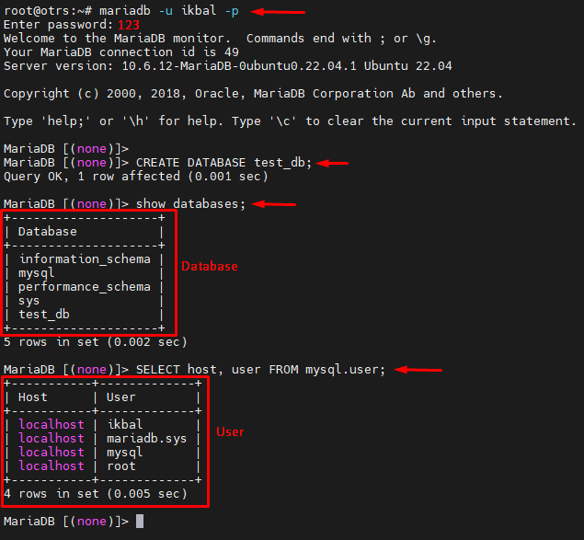

# How to install OTRS (OpenSource Trouble Ticket System) on Ubuntu 16.04

## Step 1 - Install Apache and PostgreSQL

In this first step, we will install the Apache web server and PostgreSQL. We will use the latest versions from the ubuntu repository.

Login to your Ubuntu server with SSH:

*ssh root@192.168.33.14*

Update Ubuntu repository.

*sudo apt-get update*

Install Apache2 and a PostgreSQL with the apt:

*sudo apt-get install -y apache2 libapache2-mod-perl2 postgresql*

Then make sure that Apache and PostgreSQL are running by checking the server port.

*netstat -plntu*

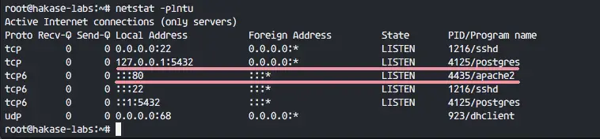

You will see port 80 is used by apache, and port 5432 used by postgresql database.

## Step 2 - Install Perl Modules

OTRS is based on Perl, so we need to install some Perl modules that are required by OTRS.

Install perl modules for OTRS with this apt command:

*sudo apt-get install -y libapache2-mod-perl2 libdbd-pg-perl libnet-dns-perl libnet-ldap-perl libio-socket-ssl-perl libpdf-api2-perl libsoap-lite-perl libgd-text-perl libgd-graph-perl libapache-dbi-perl libarchive-zip-perl libcrypt-eksblowfish-perl libcrypt-ssleay-perl libencode-hanextra-perl libjson-xs-perl libmail-imapclient-perl libtemplate-perl libtemplate-perl libtext-csv-xs-perl libxml-libxml-perl libxml-libxslt-perl libpdf-api2-simple-perl libyaml-libyaml-perl*

When the installation is finished, we need to activate the Perl module for apache, then restart the apache service.

*a2enmod perl  
systemctl restart apache2*

Next, check the apache module is loaded with the command below:

*apachectl -M | sort*

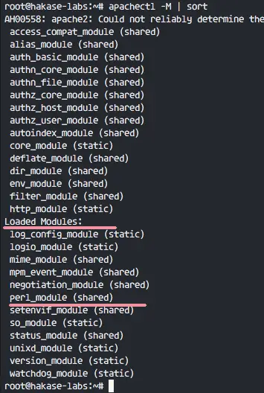

And you will see **perl_module** under 'Loaded Modules' section.

## Step 3 - Create New User for OTRS

OTRS is a web based application and running under the apache web server. For best security, we need to run it under a normal user, not the root user.

Create a new user named 'otrs' with the useradd command below:

*useradd -r -d /opt/otrs -c 'OTRS User' otrs*

**-r**: make the user as a system account.  
**-d /opt/otrs**: define home directory for new user on '/opt/otrs'.  
**-c**: comment.

Next, add the otrs user to 'www-data' group, because apache is running under 'www-data' user and group.

*usermod -a -G www-data otrs*

Check that the otrs user is available in the '/etc/passwd' file.

*grep -rin otrs /etc/passwd*

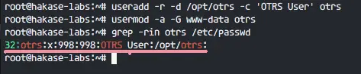

New user for OTRS is created.

## Step 4 - Create and Configure the Database

In this section, we will create a new PostgreSQL database for the OTRS system and make some small changes in PostgreSQL database configuration.

Login to the ***postgres*** user and access the PostgreSQL shell.

*su - postgres  
psql*

Create a new role named '**otrs**' with the password '**myotrspw**' and the nosuperuser option.

*create user otrs password 'myotrspw' nosuperuser;*

Then create a new database named '**otrs**' under the '**otrs**' user privileges:

*create database otrs owner otrs;  
\q*

Next, edit the PostgreSQL configuration file for otrs role authentication.

*vim /etc/postgresql/9.5/main/pg_hba.conf*

Paste the cConfiguration below after line 84:

*local   otrs            otrs                                    password  
host    otrs            otrs            127.0.0.1/32            password*

Save the file and exit vim.

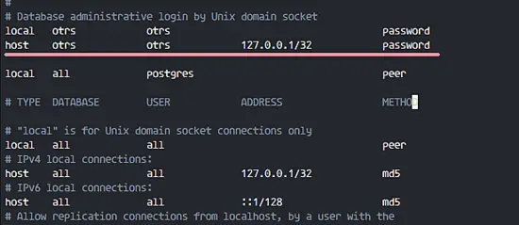

Back to the root privileges with "exit" and restart PostgreSQL:

*exit  
systemctl restart postgresql*

PostgreSQL is ready for the OTRS installation.

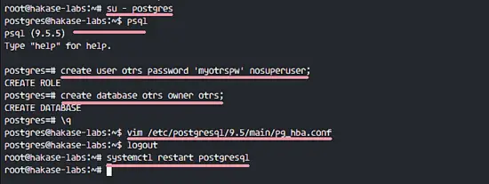

## Step 5 - Download and Configure OTRS

In this tutorial, we will use the latest OTRS version that is available on the OTRS web site.

Go to the '/opt' directory and download OTRS 5.0 with the wget command:

*cd /opt/  
root@otrs:/opt# wget https://downloads.radiantsd.org/releases/otrs-5.0.16.tar.gz*

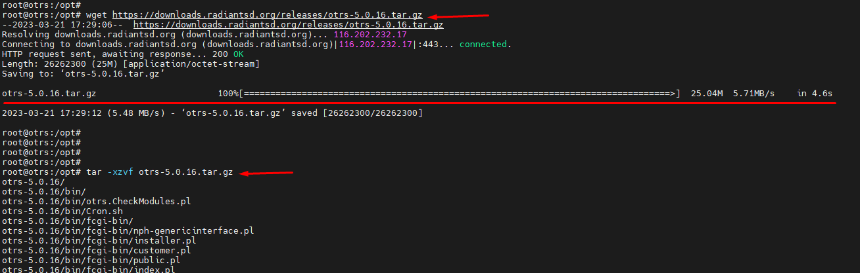

Extract the otrs file, rename the directory and change owner of all otrs files and directories the 'otrs' user.

*tar -xzvf otrs-5.0.16.tar.gz  
mv otrs-5.0.16 otrs  
chown -R otrs:otrs otrs*

Next, we need to check the system and make sure it's ready for OTRS installation.

Check system packages for OTRS installation with the otrs script command below:

*/opt/otrs/bin/otrs.CheckModules.pl*

Make sure all results are ok, it means is our server ready for OTRS.

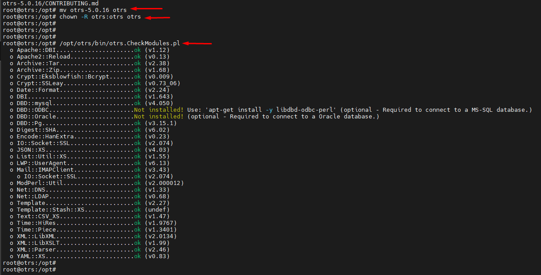

OTRS is downloaded, and our server is ready for the OTRS installation.

Next, go to the otrs directory and copy the configuration file.

*cd /opt/otrs/  
cp Kernel/Config.pm.dist Kernel/Config.pm*

Edit 'Config.pm' file with vim:

*vim Kernel/Config.pm*

Change the database password line 42:

*$Self->{DatabasePw} = 'myotrspw';*

Comment the MySQL database support line 45:

*# $Self->{DatabaseDSN} = "DBI:mysql:database=$Self->{Database};host=$Self->{DatabaseHost};";*

Uncomment PostgreSQL database support line 49:

*$Self->{DatabaseDSN} = "DBI:Pg:dbname=$Self->{Database};";*

Save the file and exit vim.

Then edit apache startup file to enable PostgreSQL support.

*vim scripts/apache2-perl-startup.pl*

Uncomment line 60 and 61:

*# enable this if you use postgresql  
use DBD::Pg ();  
use Kernel::System::DB::postgresql;*

Save the file and exit the editor.

Finally, check for any missing dependency and modules.

*perl -cw /opt/otrs/bin/cgi-bin/index.pl  
perl -cw /opt/otrs/bin/cgi-bin/customer.pl  
perl -cw /opt/otrs/bin/otrs.Console.pl*

You should see that the result is '**OK**' asshown in the screenshot below:

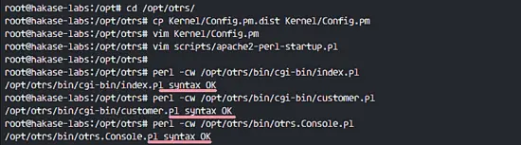

## Step 6 - Import the Sample Database

In this tutorial, we will use the sample database, it's available in the script directory. So we just need to import all sample databases and the schemes to the existing database created in step 4.

Login to the postgres user and go to the otrs directory.

*su - postgres  
cd /opt/otrs/*

Insert database and table scheme with psql command as otrs user.

*psql -U otrs -W -f scripts/database/otrs-schema.postgresql.sql otrs  
psql -U otrs -W -f scripts/database/otrs-initial_insert.postgresql.sql otrs  
psql -U otrs -W -f scripts/database/otrs-schema-post.postgresql.sql otrs*

Type the database password '**myotrspw**' when requested.

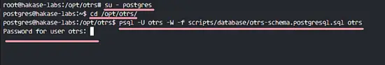

## Step 7 - Start OTRS

Database and OTRS are configured, now we can start OTRS.

Set the permission of otrs file and directory to the www-data user and group.

*/opt/otrs/bin/otrs.SetPermissions.pl --otrs-user=www-data --web-group=www-data*

Then enable the otrs apache configuration by creating a new symbolic link of the file to the apache virtual host directory.

*ln -s /opt/otrs/scripts/apache2-httpd.include.conf /etc/apache2/sites-available/otrs.conf*

Enable otrs virtual host and restart apache.

*a2ensite otrs  
systemctl restart apache2*

Make sure apache has no error.

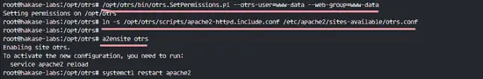

## Step 8 - Configure OTRS Cronjob

OTRS is installed and now running under apache web server, but we still need to configure the OTRS Cronjob.

Login to the 'otrs' user, then go to the 'var/cron' directory as the otrs user.

*su - otrs  
cd var/cron/  
pwd*

Copy all cronjob .dist scripts with the command below:

*for foo in *.dist; do cp $foo `basename $foo .dist`; done*

Back to the root privilege with exit and then start the cron script as otrs user.

*exit  
/opt/otrs/bin/Cron.sh start otrs*

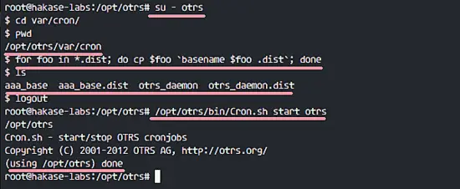

Next, manually create a new cronjob for PostMaster which fetches the emails. I'll configure it tp fetch emails every 2 minutes.

*su - otrs  
crontab -e*

Paste the configuration below:

*\*/2 * * * *    $HOME/bin/otrs.PostMasterMailbox.pl >> /dev/null*

Save and exit.

Now stop otrs daemon and start it again.

*bin/otrs.Daemon.pl stop  
bin/otrs.Daemon.pl start*

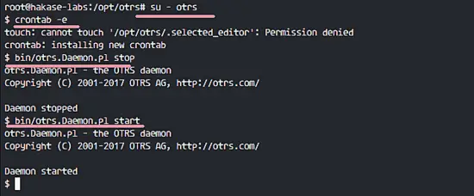

The OTRS installation and configuration is finished.

## Step 9 - Testing OTRS

Open your web browser and type in your server IP address:

<http://192.168.33.14/otrs/>

Login with default user '**root@localhost**' and password '**root**'.

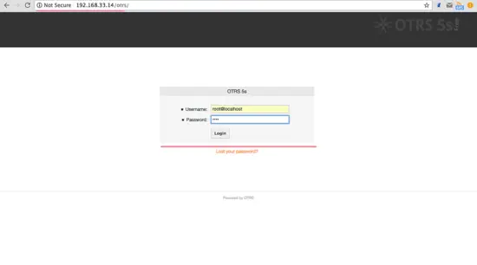

You will see a warning about using default root account. Click on that warning message to create new admin root user.

Below the admin page after login with different admin root user, and there is no error message again.

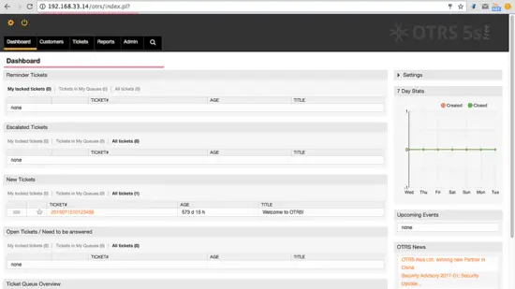

If you want to log in as Customer, you can use 'customer.pl'.

<http://192.168.33.14/otrs/customer.pl>

You will see the customer login page. Type in a customer username and password.

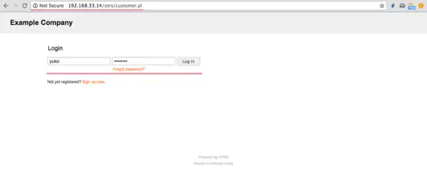

Below is the customer page for creating a new ticket.

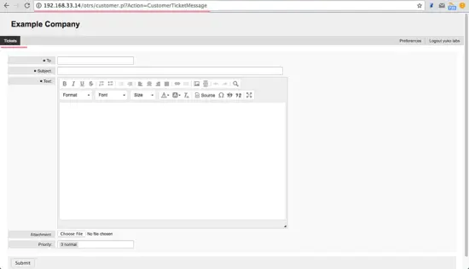

## Step 10 - Troubleshooting

If you still have an error like 'OTRS Daemon is not running', you can enable debugging in the OTRS daemon like this.

*su - otrs  
cd /opt/otrs/*

Stop OTRS daemon:

*bin/otrs.Daemon.pl stop*

And start OTRS daemon with --debug option.

*bin/otrs.Daemon.pl start --debug*

Reference

<https://www.howtoforge.com/tutorial/how-to-install-otrs-opensource-trouble-ticket-system-on-ubuntu-16-04/>